Friction

Subject:  Related Subjects: | Grade Level(s): 8  Length of Lesson: | Type: Inquiry / Design / Project  Keywords:Friction; force; static; kinetic

Lesson Overview
Use this section to describe at a high level what the lesson is. Should be no more than 3-4 lines.

Lesson Focus
What is the central question or phenomenon being investigated? What problem are they trying to solve?

Lesson Objective(s) | Students will learn about friction by studying the motion of various objects on different surfaces. They will:  - measure static friction between different materials  - measure air resistance of different surface areas

Lesson Timing

5 minutes | Introduce the Lesson
30 minutes | ...

Materials | - Small blocks of wood  -  Foam board  -  Springs (can be purchased from hardware store)  -  Sand paper  -  Aluminum foil  -  T-shirts  -  Styrofoam plate  -  Styrofoam boards  -  Hot glue  -  Calculators
Instructor Prep | - Step 1
Related Resources | - List related lessons/ppts etc available from USC or outside, trusted orgs

Lesson Plan

Introduction
Friction is a force that makes it harder for an object to slide on a surface. There are two different types of friction when talking about solid objects: static friction and kinetic friction. Static friction is the force you need to push against an object to even start to get it moving. Then, when the object starts moving across a surface, kinetic friction is the force that makes it hard to keep the object moving and slows the object down

Friction depends on the two objects that it acts between. For example, a block of wood will slide differently on tile than it does on carpet. That is because there is more friction between wood and carpet than wood and tile.

There are other forces that are similar to friction that resist motion of objects. When an object falls through the air, it experiences air resistance. Air resistance is proportional to the surface area that the object has that falls through the air, so that is why flat paper falls to the ground slower than a ball of paper.

Procedure
Board Preparation

- Cut foam board into approximately 1ft x 2ft strips
- Cut Styrofoam blocks into 1ft x 0.3ft strips
- Cut off ends of each spring so that the coil tightness is uniform across the entire spring
- Twist spring into Styrofoam board so that it sticks out of one end and not on the other (as shown in picture)
- Hot glue long end of Styrofoam board to end of foam board with the spring side facing toward the rest of the board
- Draw line across width of foam board about halfway down the length of the spring (this will be where the students will compress the spring to during the kinetic friction part of the activity)
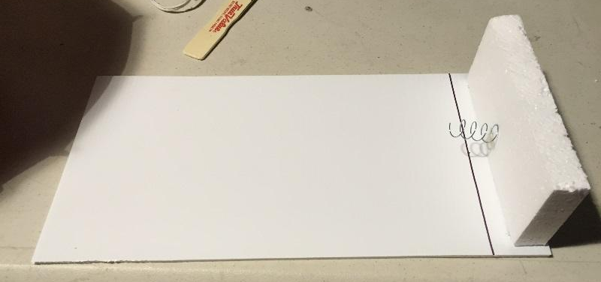

Activity Procedure

- Pass out friction worksheet
- Tell students to fill out the first section
- Once everyone is done, talk about what they answered and what they know about friction

Static Friction
- Split students into pairs
- Give every pair the foam board/spring system, a wood block, two pieces of aluminum foil, t-shirt, a plastic plate, and one strip of sand paper
- Students will be asked to fill out the table under experiment #1. They will start by laying the foam board flat on the ground and putting the wood block on the end that doesn’t have the spring attached. Then, start raising the end of the foam board that the wood block is on so that the foam board forms an angle with the ground. Continue to raise the foam board until the block starts to move down the board. They will measure the height that they had to raise the board to and record it on the table.
- They will do this for each pair of materials. Where it says “aluminum foil” under the block column, this just means wrap the block in aluminum foil. Where it says “T-shirt”, place a t-shirt in between the block and foam board.
- Either explain to the kids how to take averages, or do this part for them.
- Finally, have them rank the friction “strength” from least (1) to greatest (7).

Kinetic Friction
- This is similar to the last experiment, but this time we will measure how far an object goes when it is released from the spring.
- For each pair of materials, push the block against the spring (as far back as the line that was drawn on the board) and release it by moving your hands away very quickly
- Measure the distance from the line to the block (if you pre-draw a dot in the center of the block, it will make it more consistent if they use this point when measuring the distance to the block)
- Again, have them take the averages and rank the friction “strengths”

At the end, talk about what pairs of materials have the largest friction between them, and why they think this is the case.
\

Wrap-up
End the lesson with some final discussions about what students designed/discovered. Connect their activity back to the focus question/problem, real world examples, and STEM careers.

Also include notes about any special cleanup considerations

Lesson Background for Teachers

Suggested Real-World STEM Connections
- List possible related Role Models in STEM (with details and links to more reading). Give suggestions for examples of scientists/engineers who are from underrepresented groups in STEM in related careers.
- List related real-world engineering problems and examples

Lesson Variations and Options
Include descriptions of alternative methods or ways to present things.

Explanation
Describe the background concepts and explanations behind the lesson. This can be more in depth than a teacher/instructor would actually share with students.

Key Concepts and Vocabulary
- Word 1: Grade Appropriate Definition
- Word 2: Grade Appropriate Definition

Safety Notes
- Safety instruction

